**Institute of Engineering & Management**

**Department of Computer Science & Engineering**

**Design & Analysis of Algorithm Lab for 3rd year 5th semester 2018**

**Code: CS 591**

**Date:** 25/07/18

**WEEK-1**

**Source code:**

#include <stdio.h>

#include <stdlib.h>

void sort(int *arr, int low, int high)

{

int mid=(low+high)/2;

if(low>=high-1)

return;

else{

sort(arr, low, mid);

sort(arr, mid, high);

merge(arr, low, high);

}

}

void merge(int *arr, int low, int high)

{

int i, lp=low, rp=(low+high)/2, temp[high-low];

for(i=0;i<high-low;i++)

{

if(lp==(low+high)/2)

temp[i]=arr[rp++];

else if(rp==high)

temp[i]=arr[lp++];

else if(arr[lp]>arr[rp])

temp[i]=arr[rp++];

else if(arr[lp]<=arr[rp])

temp[i]=arr[lp++];

}

for(i=0;i<high-low;i++)

arr[i+low]=temp[i];

}

int main()

{

int *arr, i, n;

printf("Enter the no. of elements: ");

scanf("%d",&n);

arr = (int *)malloc(n*sizeof(int));

printf("Enter the elements: ");

for(i=0;i<n;i++)

scanf("%d", &arr[i]);

sort(arr,0,n);

printf("The sorted array is: ");

for(i=0;i<n;i++)

printf("%d, ", arr[i]);

printf("\n");

return 0;

}

**Screen-shot:**

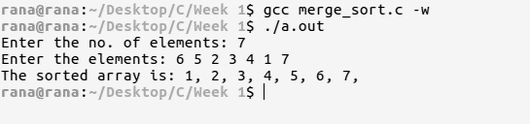

**Source code:**

#include <stdio.h>

#include <stdlib.h>

void qsrt(int n, int *arr)

{

int left = -1, right = n, pivot = arr[0], i=0, temp;

if(n<=1)

return;

while(left!=right-1)

{

if(i%2 == 0)

{

if(pivot>=arr[left+1])

{

left++;

}

else

{

temp = arr[left+1];

arr[left+1] = arr[right-1];

arr[right-1] = temp;

right--;

}

}

else

{

if(pivot<=arr[right-1])

{

right--;

}

else

{

temp = arr[left+1];

arr[left+1] = arr[right-1];

arr[right-1] = temp;

left++;

}

}

i++;

}

if(left!=-1)

{

arr[0] = arr[left];

arr[left] = pivot;

}

qsrt(left, arr);

qsrt(n-right, &arr[right]);

}

int main()

{

int *arr, i, n;

printf("Enter the no. of elements: ");

scanf("%d",&n);

arr = (int *)malloc(n*sizeof(int));

printf("Enter the elements: ");

for(i=0;i<n;i++)

scanf("%d", &arr[i]);

qsrt(n, arr);

printf("The sorted array is: ");

for(i=0;i<n;i++)

printf("%d, ", arr[i]);

printf("\n");

return 0;

}

**Screen-shot:**

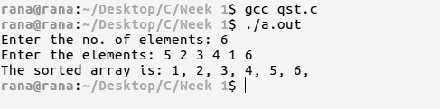

**Time complexity:**

**Source code:**

#include <stdio.h>

#include <stdlib.h>

void sort(int *arr, int low, int high)

{

int mid=(low+high)/2, lp, rp, stack[4], top = -1;

if(low == high-2)

{lp = mid-1; rp = high-1;}

else if(low == high-3)

{lp = mid-1; rp = high-2;}

else {lp = mid-2; rp = high-2;}

if(low==high-1)

return;

else{

sort(arr, low, mid);

sort(arr, mid, high);

while(lp != mid || rp!=high)

{

if(lp == mid)

stack[++top] = arr[rp++];

else if(rp == high)

stack[++top] = arr[lp++];

else if(arr[lp] < arr[rp])

stack[++top] = arr[lp++];

else stack[++top] = arr[rp++];

}

while(top+1)

{

arr[(((high-low)>4)?(high-4):low) +top] = stack[top];

top--;

}

}

}

int main()

{

int *arr, i, n;

printf("Enter the no. of elements(>1): ");

scanf("%d",&n);

arr = (int *)malloc(n*sizeof(int));

printf("Enter the elements: ");

for(i=0;i<n;i++)

scanf("%d", &arr[i]);

sort(arr,0,n);

printf("The 2nd highest is: %d\n", arr[n-2]);

printf("\n");

return 0;

}

**Screen-shot:**

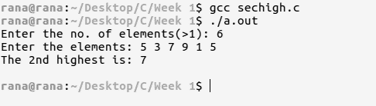

**Source code:**

#include <stdio.h>

#include <stdlib.h>

void find_sum(int n, int *arr, int x)

{

int right=n-1, left=0;

while(left<right)

{

if(arr[left]+arr[right] == x)

{

printf("%d, %d\n", arr[left], arr[right]);

left++; right--;

}

else if(arr[left]+arr[right] > x)

right--;

else left++;

}

}

int main()

{

int n, i, x, *arr, *result=NULL;

printf("Enter the no. of elements: ");

scanf("%d", &n);

arr = (int *)malloc(n*sizeof(int));

printf("Enter the elements: ");

for(i=0;i<n;i++)

{

scanf("%d", &arr[i]);

}

printf("Enter the sum value: ");

scanf("%d", &x);

find_sum(n,arr,x);

return 0;

}

**Screen-shot:**

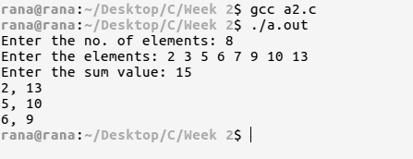

**Source code:**

#include <stdio.h>

#include <stdlib.h>

int find_row(int n, int **arr, int x)

{

int i;

for(i=0;i<n;i++)

{

if(arr[i][0]>x)

break;

}

return i-1;

}

void find(int n, int m, int **arr, int x)

{

int res, rs = find_row(n, arr, x);

if(rs == -1)

printf("Not Found\n");

else

res = search(0, m, arr[rs], x);

if(res == -1)

printf("Not Found\n");

else printf("Found in arr[%d][%d]\n", rs, res);

}

int search(int low, int high, int *arr, int x)

{

int mid = (low+high)/2, res=-1;

if(low==high-1)

if(arr[low] == x)

return low;

else res;

else if(arr[mid] == x)

return mid;

else if(arr[mid] > x)

res = search(low, mid, arr, x);

else if(arr[mid] < x)

res = search(mid, high, arr, x);

return res;

}

int main()

{

int n, m, i, j, x, **arr, *result=NULL;

printf("Enter N: ");

scanf("%d", &n);

printf("Enter M: ");

scanf("%d", &m);

arr = (int **)malloc(n*sizeof(int *));

for(i=0;i<n;i++)

arr[i] = (int *)malloc(m*sizeof(int));

printf("Enter the matrix:\n");

for(i=0;i<n;i++)

for(j=0;j<m;j++)

scanf("%d", &arr[i][j]);

printf("Enter the value: ");

scanf("%d", &x);

find(n, m,arr,x);

return 0;

}

**Screen-shot:**

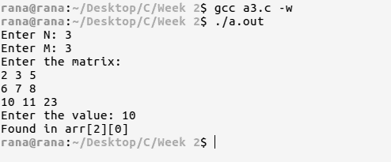

**Time complexity:**

**Source code:**

#include <stdio.h>

#include <stdlib.h>

int search1(int low, int high, int *arr, int x)

{

int mid, res=-1;

while(low<=high-3)

{

mid = (low+high)/2;

if(arr[mid]>=x)

high = mid+1;

else

low = mid+1;

}

if(low==high-2)

{

if(arr[low]==x)

return low;

else if(arr[low+1]==x)

return low+1;

else return res;

}

else if(low==high-1)

if(arr[low]==x)

return low;

else return res;

return res;

}

int search2(int low, int high, int *arr, int x)

{

int mid, res=-1;

while(low<=high-3)

{

mid = (low+high)/2;

if(arr[mid]<=x)

low = mid;

else

high = mid;

}

if(low==high-2)

{

if(arr[low+1]==x)

return low+1;

else if(arr[low]==x)

return low;

else return res;

}

else if(low==high-1)

if(arr[low]==x)

return low;

else return res;

return res;

}

int main()

{

int n, pos1, pos2, i, x, *arr;

printf("Enter N: ");

scanf("%d", &n);

arr = (int *)malloc(n*sizeof(int));

printf("Enter the array: ");

for(i=0;i<n;i++)

scanf("%d", &arr[i]);

printf("Enter the value: ");

scanf("%d", &x);

pos1 = search1(0, n, arr, x);

pos2 = search2(0, n, arr, x);

if(pos1==-1 || pos2==-1)

printf("Error\n");

else

printf("No. of occurences = %d\n", (pos2-pos1)+1);

return 0;

}

**Screen-shot:**

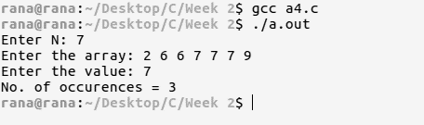

**Time complexity:**

**Source code:**

#include <stdio.h>

#include <stdlib.h>

float median(int n, int *arr1, int *arr2)

{

int L1=0,H1=n, L2=0,H2=n;

float med1, med2, max, min;

while(L1<H1-2)

{

med1 = (((H1-L1)%2==1)? arr1[(L1+H1)/2] : (float)(arr1[(L1+H1- 1)/2]+arr1[(L1+H1)/2])/2);

med2 = (((H2-L2)%2==1)? arr2[(L2+H2)/2] : (float)(arr2[(L2+H2- 1)/2]+arr2[(L2+H2)/2])/2);

if(med1==med2)

return med1;

else if(med1<med2){

L1 = (L1+H1-1)/2;

H2 = ((L2+H2)/2)+1;

}

else{

L2 = (L2+H2-1)/2;

H1 = ((L1+H1)/2)+1;

}

}

if(arr1[L1]>arr2[L2])

max = (float)arr1[L1];

else max = (float)arr2[L2];

if(arr1[L1+1]>arr2[L2+1])

min = (float)arr2[L2+1];

else min = (float)arr1[L1+1];

return (max+min)/2;

}

int main()

{

int n, i, *arr1, *arr2;

printf("Enter N(>1): ");

scanf("%d", &n);

arr1 = (int *)malloc(n*sizeof(int));

arr2 = (int *)malloc(n*sizeof(int));

printf("Enter the 1st sorted array: ");

for(i=0;i<n;i++)

scanf("%d", &arr1[i]);

printf("Enter the 2nd sorted array: ");

for(i=0;i<n;i++)

scanf("%d", &arr2[i]);

printf("The median is = %0.2f\n", median(n, arr1, arr2));

return 0;

}

**Screen-shot:**

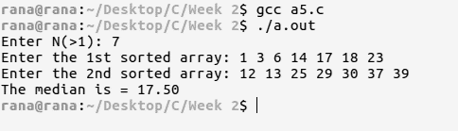

**Source code:**

#include <stdio.h>

#include <stdlib.h>

int min_arr(int n, int *arr)

{

int mid, low=0, high=n;

while(low<high-2)

{

mid = (low+high)/2;

if(arr[mid]<arr[mid-1])

return arr[mid];

else if(arr[mid]<arr[0])

high = mid+1;

else low = mid;

}

if(low==0 || high==n)

return arr[0];

if(arr[low]>arr[low+1])

return arr[low+1];

else return arr[low];

}

int main()

{

int n, i, *arr;

printf("Enter N(>1): ");

scanf("%d", &n);

arr = (int *)malloc(n*sizeof(int));

printf("Enter the array(distinct element): ");

for(i=0;i<n;i++)

scanf("%d", &arr[i]);

printf("The minimum element is = %d\n", min_arr(n, arr));

return 0;

}

**Screen-shot:**

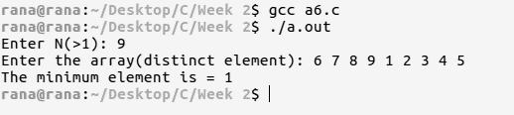

**Time complexity:**

**Source code:**

#include <stdio.h>

#include <stdlib.h>

int min_arr(int n, int *arr)

{

int mid, low=0, high=n, dif=(arr[n-1]-arr[0])/n, req;

while(low<high-2)

{

mid = (low+high)/2;

req = arr[0]+(mid*dif);

if(arr[mid]>req || arr[mid]<req)

high = mid+1;

else if(arr[mid]==req)

low = mid;

}

return arr[0]+(low+1)*dif;

}

int main()

{

int n, i, *arr;

printf("Enter N(>1): ");

scanf("%d", &n);

arr = (int *)malloc(n*sizeof(int));

printf("Enter the array: ");

for(i=0;i<n;i++)

scanf("%d", &arr[i]);

printf("The minimum element is = %d\n", min_arr(n, arr));

return 0;

}

**Screen-shot:**

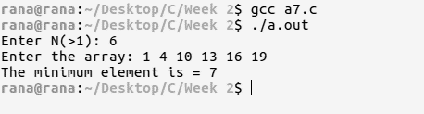

**Time complexity:**

**Source code:**

#include <stdio.h>

#include <stdlib.h>

int min_arr(int n, int *arr)

{

int mid, low=0, high=n;

while(low<high-2)

{

mid = (low+high)/2;

if(arr[mid]<arr[mid-1])

high = mid+1;

else if(arr[mid]>arr[mid-1])

low = mid;

}

if(arr[low]>arr[low+1])

return low+1;

else return low+2;

}

int main()

{

int n, i, *arr;

printf("Enter N(>1): ");

scanf("%d", &n);

arr = (int *)malloc(n*sizeof(int));

printf("Enter the Bitonic sequence: ");

for(i=0;i<n;i++)

scanf("%d", &arr[i]);

printf("The Bitonic point is = %d\n", min_arr(n, arr));

return 0;

}

**Screen-shot:**

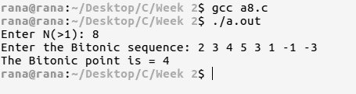

**Time complexity:**